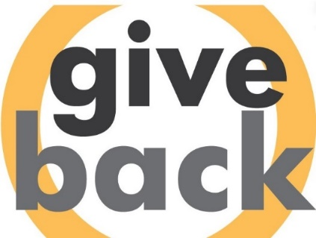

[**GIVE BACK IOWA**](https://volunteer.iowa.gov/volunteering/employers/give-back-iowa-challenge/challenge-participants)

**Engaging Employees in the Give Back Iowa Challenge**

Looking for ways to engage your employees in volunteering and participating in the Give Back Iowa Challenge? We’ve put together some ideas and resources for you to use.

**Communications Tools**

Help spread the word to your employees about the challenge by promoting it in your company newsletter, intranet, emails, break rooms and other public and virtual workspaces. We’ve created sample emails, poster templates and social media posts that you can customize for your employees.

Take photos of the various volunteer efforts or ask employees to submit selfies while volunteering. Post the photos with the hashtag #givebackiowa and a description of the volunteer work on social media or in your company’s newsletter to show the important work that employees are doing. Share your photos at [info@volunteeriowa.org](mailto:info@volunteeriowa.org) so that we can promote your employees’ volunteer work!

Encourage your CEO or leadership team members to send personalized thank you notes to each employee who participates in the challenge.

**Encourage Mentoring or Skills-Based Volunteering**

*Mentoring:* Encourage your employees to mentor through [Iowa MENTOR](https://www.iowamentoring.org/) This program provides an awesome way to volunteer and make a positive impact on youth in Iowa.

*Skills-based volunteering:* Skills-based volunteering consists of employees using their professional experience and expertise to help the community with nonprofit organizations. Most skills-based volunteer opportunities can be completed remotely and often have a set time frame for completion. It is a time commitment made by employees looking to leverage their skill sets to create social impact. It’s also an ideal way for employees to use their VTO.

Skills-based volunteering opportunities can include, but is not limited to:

* Providing graphic design assistance to design newsletters, social media graphics, invitations, etc.
* Preparing grant proposals
* Conducting an IT audit of technology used
* Providing accounting or auditing assistance
* Refreshing communications materials and talking points including media training

**Competitions/Prizes**

Have fun with the challenge by holding competitions among work divisions, locations, or departments within the state. Ask managers to schedule a volunteer activity for employees to participate in during the challenge, such as a team building exercise at your local food bank or homeless shelter. Local [Volunteer Centers](https://volunteer.iowa.gov/volunteering/organizations/volunteer-centers-iowa) can also help you find a group service project. Recognize departments who participate in a volunteer activity and offer prizes for highest participation, number of hours volunteered, or hold a drawing for a virtual pizza party or other reward day for participating in the challenge.

You can set a company goal and share weekly results via email, on your intranet, or on posters to show the number of hours logged and how your company is doing overall.

In addition, find ways to recognize employees who are volunteering during their off-work time and encourage them to submit their hours to be counted in the challenge. All volunteer hours count!

**T-shirts/Apparel**

Provide a t-shirt or other company apparel such as a ball cap or face masks to employees who sign up to track their hours for the challenge. Encourage them to wear their apparel while volunteering.

**Recognition Opportunities**

April is National Volunteer Month, so take advantage of this designation to thank and recognize your employees who volunteer for employer-supported projects or on their own personal time!

**Let us know what you're up to!**

We would love to hear about your plans for internal incentives and recognition! We will be spotlighting creative ideas throughout the challenge in press releases and on our social media platforms. Please call or send us a message to let us know how you are engaging your employees and we'll highlight your hard work. Contact Volunteer Iowa at [info@volunteeriowa.org](mailto:info@volunteeriowa.org) or 800.308.5987.

**A program of:**  **In partnership with:**

