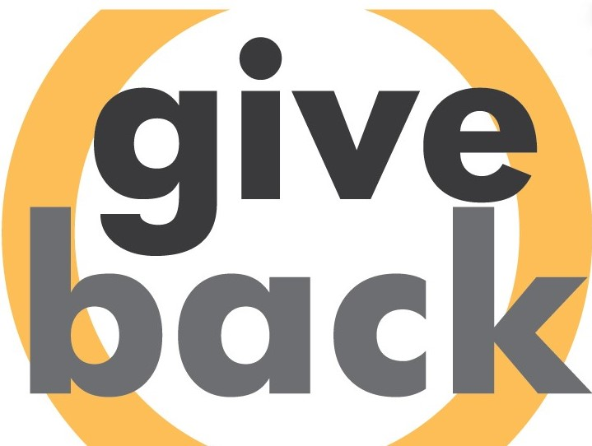

[**Give Back Iowa Challenge**](https://volunteer.iowa.gov/volunteering/employers/give-back-iowa-challenge/challenge-participants)

Join us for the TENTH ANNUAL Give Back Iowa Challenge!

April 1 - May 31

Iowa has appeared on many best-of lists over the last few years, and we think it’s time to raise our efforts in volunteering and giving back to showcase how great our state truly is.

It’s a simple, fun way to get out in your community!

Volunteer and track your hours with your employer! **Employers with the highest average number of volunteer hours per employee during the challenge period will be recognized publicly through social media and a statewide press release.**

Get your competitive spirit on and get volunteering!

Research shows that employees who volunteer experience:

1. Improved employee engagement
2. Increased organizational commitment
3. Greater job satisfaction

Will you join us?

Employers can visit the [Give Back Iowa Challenge website](https://volunteer.iowa.gov/volunteering/employers/give-back-iowa-challenge/challenge-participants) to learn more and find out how to register. Questions? Contact Volunteer Iowa at [info@volunteeriowa.org](mailto:info@volunteeriowa.org) or 800.308.5987

A program of: In partnership with:

