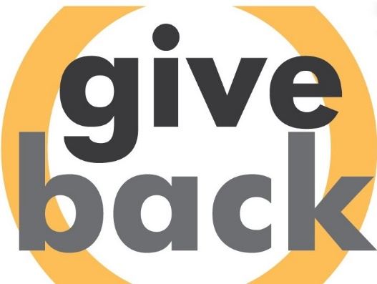

[**Give Back Iowa Challenge**](https://volunteer.iowa.gov/volunteering/employers/give-back-iowa-challenge)

**Content for Newsletters**

*Longer version*

Volunteerism at its core, has an enormous impact on the health and well-being of communities in our state. Last year over 30 organizations, both nonprofit and for-profit, took part in the [Give Back Iowa Challenge](https://volunteer.iowa.gov/volunteering/employers/give-back-iowa-challenge) organized by Volunteer Iowa.

The Give Back Iowa Challenge is an eight-week statewide employer-supported volunteer initiative, which serves as a competitive way to encourage organizations and businesses alike to participate in community volunteering. The Challenge runs from April 1st through May 31st. It’s simple; [register your organization](https://docs.google.com/forms/d/e/1FAIpQLSceDR4lAlsSxxJ0pSNmIJsYCxZ-NXJ0vnzbgSACNRpD-DHfCg/viewform), track the hours of your employees, record those hours on our system, and celebrate your employees!

The Give Back Iowa Challenge was created in 2015 by Volunteer Iowa to promote employer volunteer initiatives. These programs are proven to have a positive impact on businesses, including improved employee engagement, organizational commitment, job satisfaction, and retention. In 2023 alone, this initiative recorded nearly 30,000 hours of volunteer service in Iowa.

Since the start of the pandemic, the percent of Iowans who volunteer dropped from 53% to 42%, while the need for volunteer support has grown. As well as serving an urgent need in Iowa, research shows volunteering helps improve physical and mental health. Now more than ever, it is critical to support and grow volunteering in Iowa. Your organization can help make a difference by participating in this year’s challenge.

Past winners of the Challenge include Worldly Goods in Ames, with 6 employees participating, and Wells Fargo with thousands of participants. Any business or organization of any size can help make Iowa a better, stronger place; one hour at a time.

Registration is now open! Register your company by March 31st to be included in pre-challenge promotions. Complete information and resources on how to participate and find volunteer opportunities are provided in the [Give Back Iowa Challengetoolkit](https://volunteer.iowa.gov/volunteering/employers/give-back-iowa-challenge/challenge-participants).

*Shorter Version*

Volunteerism at its core, has an enormous impact on the health and well-being of communities in our state. Last year, nearly 30 organizations, both nonprofit and for-profit, took part in the [Give Back Iowa Challenge](https://volunteer.iowa.gov/volunteering/employers/give-back-iowa-challenge) organized by Volunteer Iowa.

Since the start of the pandemic, the percent of Iowans who volunteer dropped from 53% to 42%, while the need for volunteer support has grown. As well as serving an urgent need in Iowa, research shows volunteering helps improve physical and mental health. Now more than ever, it is critical to support and grow volunteering in Iowa. Your organization can help make a difference by participating in this year’s challenge.

The Give Back Iowa Challenge is an eight-week statewide employer-supported volunteer initiative, which serves as a competitive way to encourage organizations and businesses alike to participate in community volunteering. The Challenge runs from April 1st through May 31st. It’s simple; [register your organization](https://volunteerchallenge.iowa.gov/), track the hours of your employees, record those hours on our system, and celebrate your employees!

Registration is now open! Register your company by March 31st to be included in pre-challenge promotions. Complete information and resources on how to participate and find volunteer opportunities are provided in the [Give Back Iowa Challenge toolkit](https://volunteer.iowa.gov/volunteering/employers/give-back-iowa-challenge/challenge-participants).