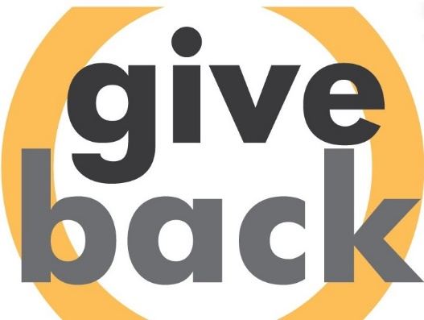

**[Give Back Iowa](https://volunteer.iowa.gov/volunteering/employers/give-back-iowa-challenge/challenge-participants)**

**Sample Social Media Posts**

1. We are joining the TENTH annual Give Back Iowa Challenge from April 1 - May 31! Learn more and join us at <https://volunteer.iowa.gov/volunteering/employers/give-back-iowa-challenge> #GiveBackIowa
2. Have you spoken to your employer yet about joining the #GiveBackIowa Challenge? It's free to register and easy to participate! <https://volunteer.iowa.gov/volunteering/employers/give-back-iowa-challenge>
3. The #GiveBackIowa Challenge recorded nearly 30,000 hours in 2023. Let's work together to record even more! Sign up today at <https://volunteer.iowa.gov/volunteering/employers/give-back-iowa-challenge>
4. A company of 1 to a company of 10,000 - it doesn't matter the size to join the #GiveBackIowa Challenge! Join us at <https://volunteer.iowa.gov/volunteering/employers/give-back-iowa-challenge>
5. Employer-supported volunteering leads to improved retention, well-being, and job satisfaction. Sign up for the #GiveBackIowa Challenge and celebrate your employees! <https://volunteer.iowa.gov/volunteering/employers/give-back-iowa-challenge>
6. Join the Give Back Iowa Challenge from April 1 - May 31! Our company is in, are you? Learn more at <https://volunteer.iowa.gov/volunteering/employers/give-back-iowa-challenge>
7. Our competitive spirit is ready for Give Back Iowa! We've joined the challenge and invite you to learn more at <https://volunteer.iowa.gov/volunteering/employers/give-back-iowa-challenge>
8. We challenge YOU, XXXX (company/organization) to see who can log the most volunteer hours! Join the challenge with us at <https://volunteer.iowa.gov/volunteering/employers/give-back-iowa-challenge>
9. Our employees have already volunteered with over XX organizations in the first XX weeks of the #GiveBackIowa Challenge! <https://volunteer.iowa.gov/volunteering/employers/give-back-iowa-challenge>
10. Our goal is to be #1 in the #GiveBackIowa Challenge! Volunteering is vital to our community - won't you join us? <https://volunteer.iowa.gov/volunteering/employers/give-back-iowa-challenge>
11. Volunteering strengthens the community, but that doesn’t mean we can't get competitive 😊 Join the #GiveBackIowa Challenge and see if you can beat our current tally of xxxx volunteer hours! <https://volunteer.iowa.gov/volunteering/employers/give-back-iowa-challenge>
12. Bragging rights go to this year's #GiveBackIowa challenge winner. How many hours can YOU volunteer? <https://volunteer.iowa.gov/volunteering/employers/give-back-iowa-challenge>
13. Right now, our employees have collectively volunteered xx hours for the #GiveBackIowa challenge! What are YOU doing for your community? Join the challenge and make a difference. <https://volunteer.iowa.gov/volunteering/employers/give-back-iowa-challenge>
14. Volunteering is crucial to solving some of our state's biggest challenges. Sign up for the #GiveBackIowa Challenge! <https://volunteer.iowa.gov/volunteering/employers/give-back-iowa-challenge>