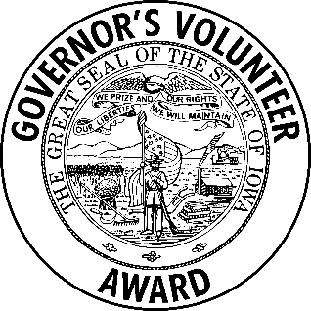
FOR IMMEDIATE RELEASE
Contact: LOCAL CONTACT INFORMATION

LOCAL CITIZEN(S) RECEIVE(S) GOVERNOR’S VOLUNTEER AWARD

CITY, STATE – NAME OF INDIVIDUAL OR GROUP of CITY received a Governor’s Volunteer Award from Governor Kim Reynolds and Lt. Governor Chris Cournoyer during a special recognition ceremony held Wednesday, June 4 in Urbandale.

NAME OF INDIVIDUAL OR GROUP was honored with a[an] INDIVIDUAL / GROUP / LENGTH OF SERVICE award by NOMINATING ORGANIZATION for DESCRIPTION OF VOLUNTEER'S ACTIVITY.

More than 290 awards are being presented this year. It is estimated that 96 communities in Iowa were served by this year’s honorees.

“Those being recognized are the people who invest in others without expecting anything in return—except, of course, for the fulfillment that comes from doing their part to give back to their community,” said Gov. Kim Reynolds. “This collective impact is nothing short of remarkable.”

Coordinated by Volunteer Iowa, a bureau within the Iowa Department of Health and Human Services (Iowa HHS), the Governor's Volunteer Award program—now in its 41st year—provides an easy way for Iowa nonprofits, charitable organizations, and government entities to honor their volunteers with a prestigious, state-level award. More information is available at volunteeriowa.org.

###

A complete list of award recipients and an electronic copy of this news release are available at volunteeriowa.org.

About Volunteer Iowa
Volunteer Iowa—a bureau within Iowa HHS--and its partner agencies work with organizations and individuals on three main fronts. The first is to help agencies develop quality programs that use service as a strategy to fulfill their missions and address Iowa’s greatest areas of need. The second is to help engage Iowans in their communities by promoting service and expanding the volunteer base. Finally, the third area of work is to connect individuals with appropriate service opportunities by building volunteer infrastructure. More information is available at volunteeriowa.org.

