ATTACHMENT 11: Detailed Budget Instructions for Fixed Amount Grants
(eGrants Budget Section)
These instructions apply only to applicants for fixed-amount grants, including education award programs (EAPs). Do not use if you are a Professional Corps applicant.

EAP and Fixed-Amount grant applicants may only request a fixed amount of funding per MSY. Therefore, Fixed-Amount applicants are not required to complete a detailed budget or complete the grantee share column. However, you must complete the source of match chart to identify the sources of the additional revenue you need to operate the program. If you are applying for a full-cost fixed-amount grant, you must pay at least the minimum living allowance listed in the RFA for each type of position you are proposing.

Budget Section II. AmeriCorps Member Positions

Member Positions
Identify the number of members you are requesting by category (i.e., full-time, three quarter-time, half-time, reduced half-time, quarter-time, minimum-time, abbreviated-time) and list under the column labeled #w/o Allow (without AMERICORPS-funded living allowance.) In the Allowance Rate field, enter the average amount of the living allowance for each type of member. Enter zero in the column labeled #Mbrs w/ Allow. Leave all other columns blank. See example below (applies to a Full-Cost Fixed Amount grant):
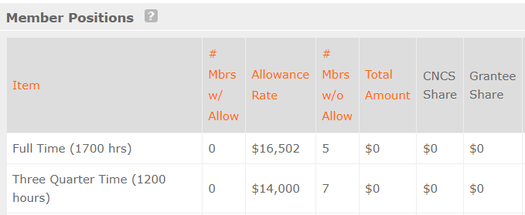

The total number of member service years (MSY) will automatically calculate at the bottom of the Member Positions chart. The MSY are calculated as follows:
Member Positions | Calculation | MSY
_____Full-time (1700 hours) | (______ members x 1.000) | =
_____Three quarter-time (1200 hours) | (______ members x .7000000) | =
_____Half-time (900 hours) | (______ members x 0.500) | =
_____Reduced half-time (675 hours) | (______ members x 0.3809524) | =
_____Quarter-time (450 hours) | (______ members x 0.26455027) | =
_____Minimum-time (300 hours) | (______ members x 0.21164022) | =
_____Abbreviated-time (100 hours) | (______ members x 0.05627705) | =
 | Total MSY
Total # of MSYs ________ | x MSY amount (See RFA for amounts)____ | = Total Grant Request $____

Fixed Award
Display your calculation in the following format:
Total # of MSYs ________ | x MSY amount (See RFA for amounts)____ | = Total Grant Request $____
Type the total amount requested in the “Total Amount” and “AmeriCorps Share” columns. Leave the “Grantee Share” blank. See example below (applies to a Stipended Fixed Amount grant):

Purpose | Calculation | Total Amount | CNCS Share | Grantee Share
Program Grant Request | 47.5 MSY  X $9,500/MSY | $451,250 | $451,250 | $0
Subtotal |  | $451,250 | $451,250 | $0

Source of Funds
Match | Description

Volunteer Iowa Guidance on Budget Requirements for Fixed- Amount Grants
Applicants for Fixed-Amount grants should be aware that, although not included in the budget submitted in eGrants, the following requirements also apply to Fixed-Amount Grantees:
- Volunteer Iowa expects fixed-amount grants to attend the same trainings as other operational grantees and therefore should have a staff travel budget sufficient to cover the trainings- see Detailed Cost Reimbursement Budget Instructions
- Fixed-Amount Grantees may choose to participate in the proposed Program Council and optional joint member trainings. Suggested budget amounts are noted in Detailed Cost Reimbursement Budget Instructions.
- AmeriCorps members are required to wear the AmeriCorps logo during service so Fixed-Amount grantees should plan for the cost of providing member gear with the required logo.
- All members must receive an orientation and Life After AmeriCorps training. Volunteer Iowa encourages programs to invest in additional member training and professional development.
- Evaluation requirements also apply to Fixed-Amount grantees, who should budget accordingly.
- The National Service Criminal History Check (NSCHC) requirements apply to members of fixed-amount grants and programs should budget to cover the costs of required NSCHC.
- Volunteer Iowa will charge Member Management System Costs of $18/member. See Final Application Instructions for details.
- Volunteer Iowa will charge a State Support fee to programs, to be calculated as noted in the RFA materials.
- Member living allowance and benefits rules apply to Fixed-Amount programs- see RFA for details.

