ATTACHMENT 3: eGrants Indirect Cost Rate (IDCR) User Instructions

eGrants Indirect Cost Rate (IDCR) User Instructions
A new feature has been introduced to eGrants which allows users to input Indirect Cost Rate information into their eGrants account. Grantees that will be claiming indirect costs on AMERICORPS awards are required to enter the following indirect cost rates in eGrants: federally negotiated rates, state negotiated rates, and the use of de minimis rate of 10% of modified total direct costs (MTDC). Recipients of AmeriCorps State and National awards may only charge 5% of their negotiated rate to the federal share of the award, with the remaining balance being charged to match (See 45 CFR §§ 2521.95 and 2540.110).
Once a rate is entered & saved in eGrants, it cannot be edited. If users inadvertently enter incorrect information, a new entry must be submitted with the correct information.

Entry for the IDCR screen can be accessed using the following steps:

- From the eGrants home screen, in the lower panel under Managing My Account, click on My Account
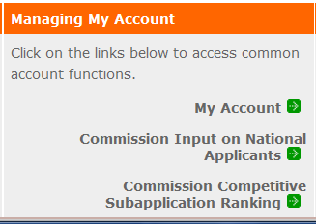

- From the My Account screen, under Edit My Organization Info, click on Add and View Indirect Cost Rate
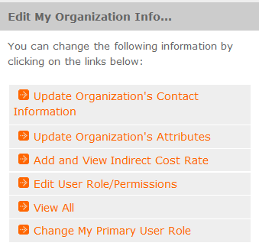

- From the Add and View Indirect Cost Rate screen, select add a new to add a rate or cancel to back out of the screen.

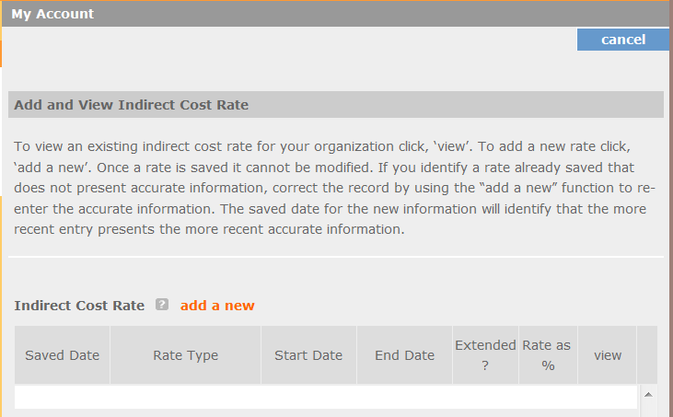

Field by field instructions can be found by clicking the “?” located next to Indirect Cost Rate or Indirect Cost Rate Record.
If add a new is selected, the screen below will pop up.
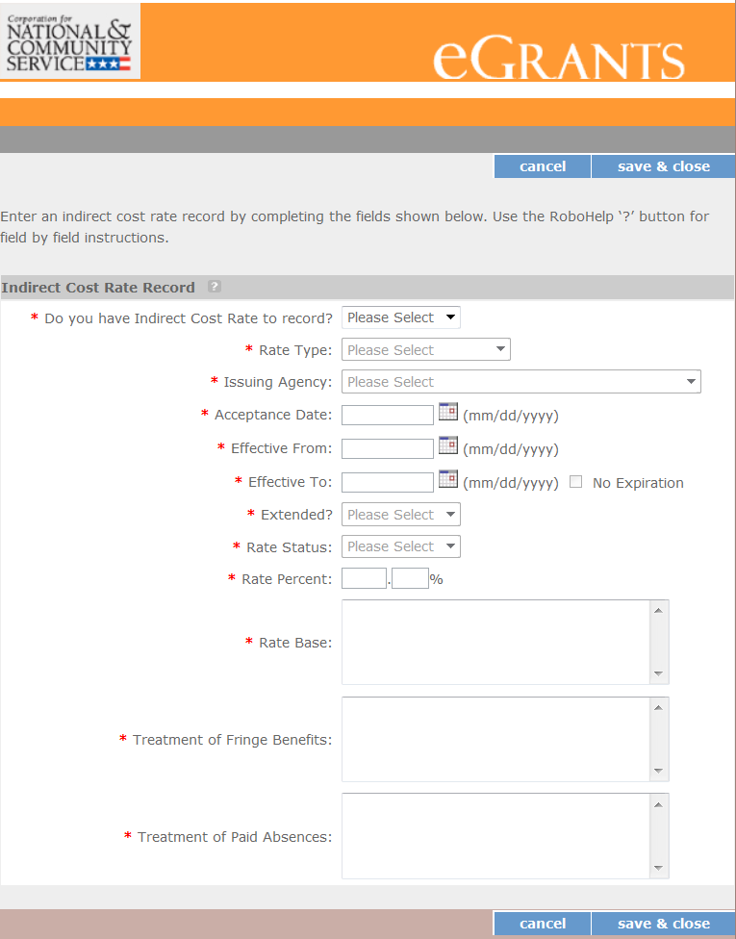

- Do you have an Indirect Cost Rate to record? Respond Yes or No. If NO is selected, users cannot go any further and nothing will be recorded. If YES is selected, users can continue on.

If your organization will be claiming a current, approved indirect cost rate on any AMERICORPS award, it must be reported on this page. The rate information you record will be used in all award negotiation, and reviews until it is superseded by a new approved rate or expires. Applicants will have the opportunity to identify, in application submissions, if they elect to use a lesser percentage of an approved rate.

- Rate Type: If your rate type is not one of the following options, contact your grants officer for guidance:
Federally Negotiated – select if your rate has been negotiated by your cognizant federal agency. Cognizance is determined by the agency which provides the highest amount of direct federal funding;
State Negotiated – select if your rate has been negotiated by a state agency or other pass-through entity; or
10% of MTDC – select if your organization qualifies for & elects to use the 10% de Minimis rate of Modified Total Direct Costs (MTDC). Organizations qualify for this rate if they have NEVER had a federally negotiated rate. State entities must also not receive more than $35 million in direct federal funding.

Rates must be used consistently across ALL federal awards.

- Issuing Agency. Respond by selecting the federal agency that approved your rate, or if the federal agency who issued your rate is not listed, select Other, or if your rate is issued by a state agency select Other.
Identify federal agencies using the drop-down list. If your rate is approved by a federal agency other than the ones listed, notify your grants officer. Other federal agencies may be added as needed.

- Acceptance Date. Enter a valid date.
The acceptance date is usually identified where the rate was signed by the issuing state or federal agency.

- Rate Status. Select one of the following options: Final, Provisional, Predetermined, Fixed, Other, or Other – 10%.
Rates issued by federal agencies will almost always be final or provisional. However, if your organization has formally notified a federal or state agency of your eligibility and intent to use the 10-percent of MTDC rate, select Other – 10%. If your organization has a predetermined or fixed rate, select those options accordingly. If a state rate indicates a term that is not listed here, select Other and notify your grants officer. Additional rate status options may be added as needed.

- Effective From. Enter a valid date.
The effective from date is found on your indirect cost rate document. If using the 10-percent of MTDC rate, enter today’s date or the date your organization formally started charging costs under the 10-percent of MTDC rate.

- Effective To. Enter a valid date.
The effective to date is found on your indirect cost rate document. If your organization has received approval to extend your rate, enter the end date of the extension.

- No Expiration. Check or leave unchecked.
If your rate does not have an expiration date, as is the case with the use of the 10-percent of MTDC rate, check this box, otherwise, leave unchecked.

- Extended? Respond Yes or No.
If the rate “effective to” date has been extended with approval of the federal cognizant agency under authority of the 2014 Omni Circular, respond Yes. If it is not an extended rate effective to date, respond No.

- Rate Base. Enter up to 500 characters including spaces.
Enter the text as found on your indirect cost rate approval document. For rates issued by state agencies, enter either the rate base used to determine the indirect cost pool as stated on your indirect cost rate approval document or “State Rate N/A.” If you need more than 500 characters, indicate “Summary” and record the most important content.

- Treatment of Fringe Benefits. Enter up to 500 characters including spaces.
Enter the text as found on your indirect cost rate approval document. For rates issued by state agencies, enter either the how fringe benefits were treated in determining the indirect cost rate as stated on your indirect cost rate approval document or “State Rate N/A.” If you need more than 500 characters, indicate “Summary” and record the most important content.

- Treatment of Paid Absences. Enter up to 500 characters including spaces.
Enter the text as found on your indirect cost rate approval document. For rates issued by state agencies, enter either the how paid absences were treated in determining the indirect cost rate as stated on your indirect cost rate approval document or “State Rate N/A.” If you need more than 500 characters, indicate “Summary” and record the most important content.

- When you have completed all the above entries, click the “save & close” button at the bottom of the page.
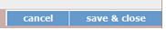

- If you would like to cancel your entry, click the “cancel” button and the entry will be cancelled. All entry information will be lost & no entry will be shown.
- Once a rate is saved it cannot be modified.
- If users inadvertently enter incorrect information, a new entry must be submitted with the correct information.

- Order of Rates - Once an entry is saved, users will be able to see the rates they have entered. Rates will be displayed in the order of entry. Entry of rates will provide users and AMERICORPS with a historical record which can be used to clarify indirect cost rate inquiries for monitoring, consistent record maintenance, and audits.

If you have any questions or concerns, please contact Volunteer Iowa.

